Lesson Four (Teacher)
“The Dual Nature of Ozone – Stratospheric Ozone”

Objective
Students have already learned about the most common gases in the atmosphere. Now they will begin to learn about how other substances in the atmosphere can strongly affect their health and the environment, even in minute concentrations. In this lesson, students will learn about stratospheric ozone and the difference between this high-level ozone (which protects the Earth from ultraviolet radiation) and low-level ozone (which is an air pollutant).
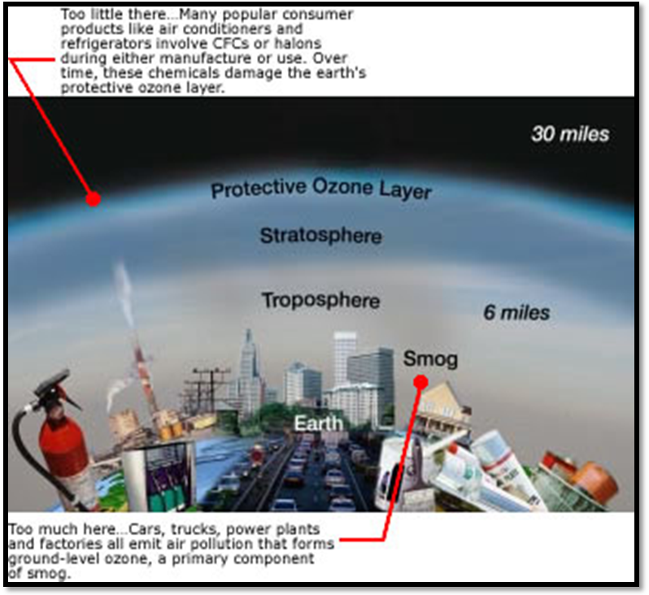

Stratospheric ozone forms naturally and protects us from ultraviolet radiation.
Tropospheric ozone forms from air pollutant emissions and harms human health.
Credit: U.S. EPA: “Ozone Good Up High, Bad Nearby”

Background Information
Most of the oxygen in the atmosphere, and the type that we need to sustain life, has two atoms per molecule (O₂). Ozone, by contrast, has three oxygen atoms (O₃). Ozone forms naturally in the stratosphere when intense ultraviolet radiation from the Sun splits an oxygen molecule (O₂) into two O atoms. Each O can then combine with another O₂ to form O₃. [Note: The concept of molecules composed of atoms is above the 5th grade level; for your explanation to students, you can state that the Sun’s intense UV radiation splits oxygen to form ozone].
About 90 percent of the ozone in the Earth’s atmosphere is found in what is known as the ozone layer in the stratosphere (about 10-30 miles above Earth’s surface). The ozone layer absorbs most of the Sun’s ultraviolet radiation to shield us from these damaging rays. Ultraviolet rays can cause a range of negative effects: they can cause cancer, burn skin, damage eyes, weaken the human immune system, and harm both plants and animals. In fact, estimates show that a one percent reduction in the ozone layer results in a two to five percent increase in the number of cases of cancer!
Certain air pollutants can damage the ozone layer. The most dramatic depletion of the ozone layer is the Antarctic ozone hole. In the early 1980s, scientists discovered major thinning of the ozone layer above Antarctica during springtime. In fact, they observed nearly 70% less ozone than had been found there previously! Scientists realized that the depletion of the ozone layer is caused by the release of certain chemicals such as chlorofluorocarbons (CFCs) into the atmosphere. Just a few decades ago, CFCs were used in air conditioners, aerosol sprays, and cleaning products. When CFCs reach the stratosphere, they react with the sunlight to release chlorine atoms, which can destroy ozone molecules. In 1989, an international agreement known as the Montreal Protocol was signed to ban the most destructive ozone-depleting gases and preserve the ozone layer. If the agreement is adhered to, it is hoped that the ozone layer will completely recover by 2050.

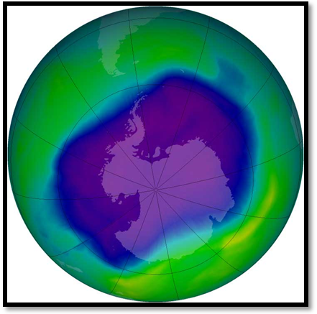
From September 21-30, 2006 the average area of the ozone hole was the largest ever observed. In this image, from Sept. 24, 2006, the Antarctic ozone hole was equal to the record single-day size of 11.4 million square miles.
Credit: http://www.nasa.gov/centers/goddard/news/topstory/2006/ozone_record.html

As we have seen, the ozone layer in the stratosphere is a vital layer of protection for the Earth. This layer that contains most of the atmosphere’s ozone is far above the air that we breathe every day, and even above the altitude where most airplanes fly. However, when ozone forms near the surface in the troposphere, where humans breathe, it is an air pollutant that can harm our lungs and the natural environment. This tropospheric ozone is the same molecule as in the stratosphere. However, in the troposphere, ozone forms in very different ways than in the stratosphere. We’ll learn more about tropospheric ozone and other air pollutants in Lesson Five.

Additional Resources
More information about good and bad ozone can be found at http://www.epa.gov/airnow/gooduphigh - a booklet by the EPA called Good Up High, Bad Nearby. Other great resources regarding ozone can be found at:
- http://www.epa.gov/ozone/strathome.html.
- http://www.windows.ucar.edu/tour/link=/Earth/Atmosphere/ozone_overview.html&edu=mid
- http://www.clean-air-kids.org.uk/ozonehole.html
- Comic strip from US EPA illustrating the two types of ozone: http://www.epa.gov/ozone/sciencem /missoz/index.html.

Vocabulary

- ozone
- ozone layer
- ultraviolet rays
- Antarctic ozone hole
- Chlorofluorocarbons (CFCs)
- Montreal Protocol
- Environmental Protection Agency
- Asthma
- Cancer
- Tropospheric ozone
- Stratospheric ozone

Materials (for a class of 25)

- Hygrometer (1 per class)
- Infrared Thermometer (1 per class)
- Ozone Test Strips (1 per class)
- Ozone Scanner (1 per class)
- Wind Vane (1 per class)
- Thermal Glove (1 per class)
- Cloud Charts (1 per class)
- GLOBE Measurement Data Sheets (1 per student)
- Computer
- Access to Brainpop.com
- Projection screen

Step-by-Step Suggested Lesson Plan
Instructor Activity  - Measurements. Take your students outside and conduct the GLOBE protocols. Students should set up the ozone strip, take the air and surface temperature, observe the sky for clouds, and measure humidity and wind direction.  - Discussion. Ask students to think of examples of things that are good in one location, but bad somewhere else (e.g., a lion in a zoo, the flame of a candle, etc.). Explain that ozone is a gas that is “Good Up High, Bad Nearby”: up high it shields Earth from radiation, but nearby it is harmful to breathe. (See “Background Information” for details and links to resources).  - Video. “Ozone Layer” on Brainpop.com provides a good overview of stratospheric ozone.  - Discussion: Go into more detail about “good” stratospheric ozone. Ex: How ozone is formed, where the layer can be found, and how it protects our health from UV rays.  - Visual. Show students a picture of the ozone hole. Explain that the hole occurs over Antarctica each September, and that the Montreal Protocol has banned some of the air pollutants (CFCs) that cause it.  - Measurements. Take your class outside, and scan the ozone strip. Also, retake the surface and air temperature, and the humidity so that students can take the average of these measurements to supplement their ozone measurements. | Student Activity  Students take measurements and write down their results on their data sheets.  Students participate in brainstorming and answer related questions on p. 1.  Students watch video and answer related questions (p. 2)  Students listen and answer questions: (p. 3)  Students listen and answer question: (p.3)  Students take measurements and write down their results on their data sheets.

Expected Outcomes
- Students can explain the “dual” nature of ozone – it can act as both a major air pollutant and as a layer of protection for the Earth.
- Students can define stratospheric ozone, know how it is formed, and know the causes and effects of ozone depletion.
- Students complete Lesson Four Journal Activities.

The dramatic thinning of ozone over the South Pole does not last for the entire year. Instead, it usually occurs in September or October (Antarctic springtime) and “fills in” or disappears by December. Special conditions in the Antarctic winter make its stratospheric ozone especially sensitive to depletion by chlorine when the sun returns in the early spring. Outside of Antarctica, slight reductions in stratospheric ozone have also been observed over most of the planet.

